
BEVERLEY GRAMMAR SCHOOL

Teacher of Design & Technology
Recruitment Information Pack

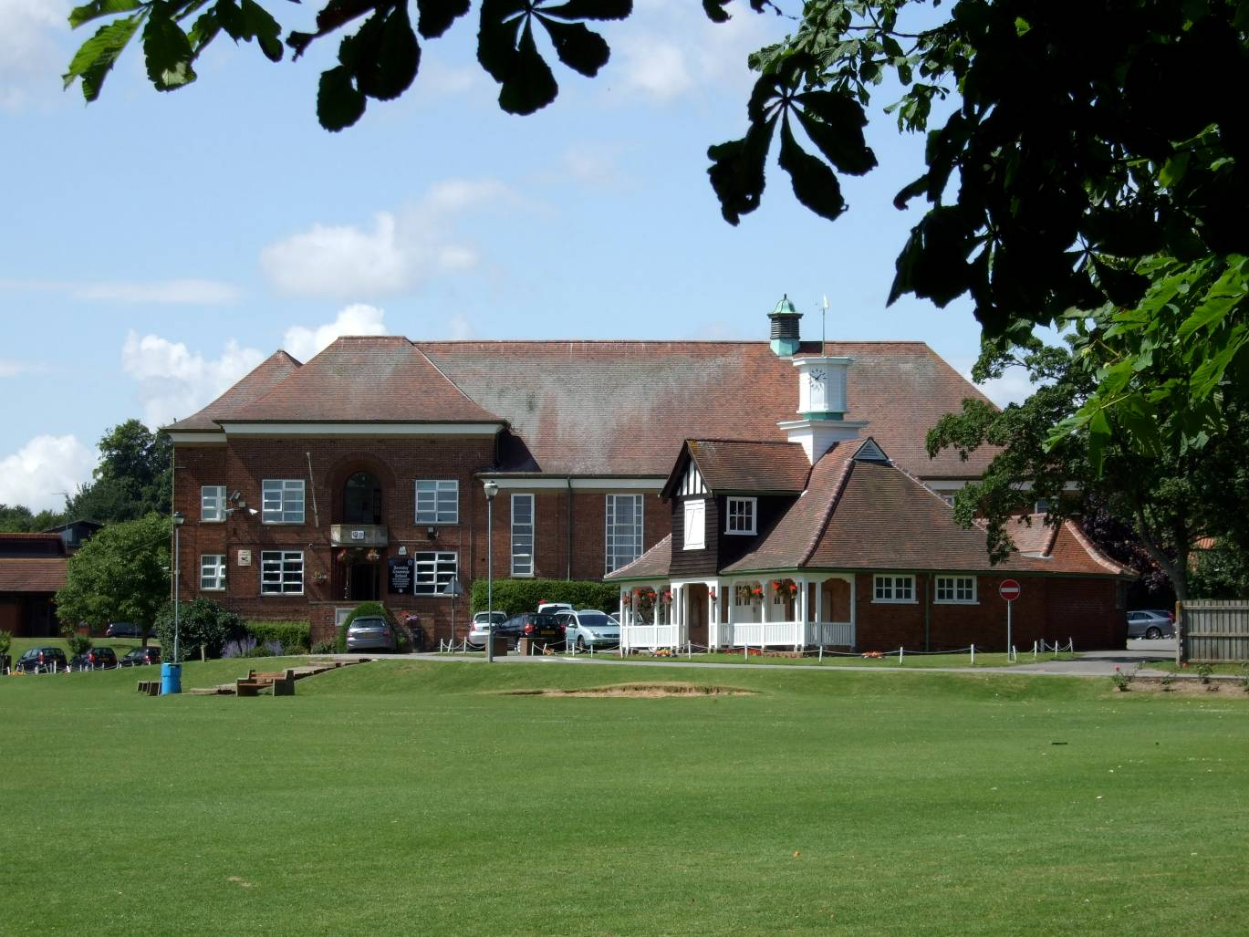

Beverley Grammar School
Queensgate
Beverley
East Yorkshire
HU17 8NF

BEVERLEY GRAMMAR SCHOOL

Teacher of Design & Technology
Recruitment Information Pack

Contents

Letter from Gavin Chappell, Headteacher .............................................................................................. 3

Beverley Grammar School Mission Statement …. ……………………………………………. 4

Application Process ………………………………………………………………………………… 5

Vacancy Advert …………………………………………………………………………………….. 6

Department Information ……………………………………………………………………………. 7/8

Job Description …………………………………………………………………………………….9/10

Person Specification ………………………………………………………………………………… 11



BEVERLEY GRAMMAR SCHOOL
Founded 700AD

Queensgate | Beverley | HU17 8NF
Headteacher Tel: 01482 881531| Fax: 01482 881564
Gavin Chappell email:office@beverleygrammar.co.uk
web:www.beverleygrammar.co.uk

March 2018

Dear Applicant

Thank you for taking an interest in the post of Teacher of Design & Technology, here at Beverley Grammar School. I look forward to receiving your application form and supporting letter.

Beverley Grammar School is an all boys’ 11-18 comprehensive school situated in the picturesque historic market town of Beverley. It operates a joint sixth form with Beverley High School, the all girls’ school. It prides itself on its ethos and is committed to raising the academic achievements of all our students.

The Design & Technology department is led by an ambitious and inspirational leader, supported by a dedicated team.

We are looking to appoint an enthusiastic, addition to our team and seek a highly motivated, inspirational teacher to teach Design & Technology across all key stages, one who has some experience using 3D CAD software and has practical knowledge of working within a workshop.

The attached documents include a Job Description, Person Specification, details about the Design and Technology Department as it currently stands, and a school application form. Please outline in your supporting letter, of no more than 2 sides of A4, how your experience and qualities will match the details given.

If you are enthused by these challenges, I look forward to hearing from you by the closing date of 20th April 2018. Interviews will take place week commencing 23rd April 2018 and selected candidates will be informed by e-mail. Further details will be provided once shortlisting has taken place.

Yours faithfully

Gavin Chappell
Headteacher

Encs



BEVERLEY GRAMMAR SCHOOL

Mission Statement

Our aims are for students to

- Have the ambition and confidence to achieve their dreams
- Act with self-awareness and tolerance
- Have the independence and resilience to overcome barriers

In order to achieve these aims we will strive to

- Set high expectations and standards in all areas of school life
- Provide a consistent, respectful and highly supportive environment
- Create opportunities for students to become leaders
- Value the achievements and contributions of all students
- Make students experience at BGS memorable

BEVERLEY GRAMMAR SCHOOL

THE APPLICATION PROCESS

Completed applications should be:-

Posted to Mrs T. Simkin,
Beverley Grammar School,
Queensgate,
Beverley,
HU17 8NF.

Emailed to apply@beverleygrammar.co.uk

Short-listed candidates will be contacted by email with details of the interview process. If you have not heard from us within 2 weeks of the closing date please assume your application has been unsuccessful.

Queries

If you have any queries on any aspect of the application process or need additional information, please contact Mrs T. Simkin in the first instance on 01482 881531.

THE CLOSING DATE FOR APPLICATIONS IS:

Friday 20 April – 10.00am
Interviews – Wk Commencing 23 April


Beverley Grammar School
Queensgate
Beverley
East Riding of Yorkshire
HU17 8NF
Headteacher: Gavin Chappell

Tel: 01482 881531

A Teacher of Design & Technology is required for September 2018

Closing Date: 20 April – 10.00am
Interview Date wk commencing 23 April
Salary: MPS
Contract type: Full-Time, Permanent

We wish to appoint an enthusiastic Design & Technology specialist to join a popular department in this all boys’ 11 – 18 comprehensive school. The department delivers Product Design, Food Technology, and Engineering at KS3, Design & Technology, Food and Nutrition and Engineering at KS4, with Design & Technology also being taught at A Level.

The successful candidate would ideally be able to teach Engineering, Product Design and Resistant Materials, as well as contributing to other areas of the department. We are seeking an outstanding classroom practitioner with a passion for developing these subjects, who can demonstrate the commitment and determination to raise standards across all levels and abilities.

Applications from NQT’s are welcome.

Further details and application forms are available at www.beverleygrammar.co.uk Completed forms should be posted to Mrs T Simkin, or emailed to apply@beverleygrammar.co.uk

Visits to the school are encouraged; please contact Kelly Smith, SLT Admin Manager, to make arrangements (k.smith@beverleygrammar.co.uk)

Beverley Grammar School is committed to safeguarding and promoting the welfare of children, young people and vulnerable adults. Clearance from the Disclosure and Barring Service is required prior to appointment.

BEVERLEY GRAMMAR SCHOOL



THE DESIGN & TECHNOLOGY DEPARTMENT
The Design & Technology department is an experienced, hard-working and dynamic group of teachers who have a passion for engaging students in Design & Technology education. There are currently four teaching staff, one full-time and one part-time technician. We work closely as team, sharing ideas, expertise and best practice to create a positive working environment. We are looking for someone who is eager to join our enthusiastic team at this exciting time. With the development of the new KS3 curriculum currently underway and the designing of new provision for the new GCSE and A level qualifications in the coming years, there’s plenty of scope to contribute your ideas and help shape the curriculum within the department. Design & Technology is taught in mixed ability groups throughout all Key Stages and is an increasingly popular subject amongst the pupils.
At Key Stage 3, the department runs a ‘carousel’ system, allowing Year 7, 8 and 9 students to experience Food Technology, Product Design and Engineering subjects over the course of their career in KS3. This ensures informed Options choices can be taken during Year 9. Class sizes at Key Stage 3 are no larger than 25.
At KS4 we deliver GCSE Courses in Food and Nutrition, and Design & Technology alongside V-Cert Courses in Engineering.
At KS5 we deliver A Level Courses in Design & Technology in conjunction with our sixth form partner school, Beverley High School.
Our teaching staff are regularly praised for the quality of their teaching and we continue to develop and review working practices in light of new initiatives.

The aims of the department are;
- To aim to develop a passion for Design & Technology in all pupils
- To provide pupils with knowledge, skills and relevant experiences which will be of value in their present and future lives.
- To provide an effective, varied and enjoyable learning experience for every pupil.
- To employ teaching methods and resources that allow for inclusion of all pupils to give them equal access to Design & Technology and to allow them to experience success and enjoyment in their work.
- To develop manipulative skills, communication skills and social skills.
- To strive for a consistently high standard of written and practical work.
- To encourage pupils to appreciate that Design & Technology can be the practical application of other subjects in their curriculum.
- To ensure that pupils develop an understanding of the ethical issues relating to the introduction of new technologies.

We have a curriculum based upon the importance of designing, making and evaluating real products and designing in challenging and engaging contexts.
As a department we have access to:
- Four classrooms with interactive whiteboards and projectors one of which is a fully equipped and newly refurbished Food Room.
- 4 Digital Cameras for recording pupils practical work.
- A range of machining options across the three workshops including centre lathes, milling machines, plastic forming machines and wood turning lathes.
- A range of CAD/CAM facilities including a new laser cutter, a 3D printer and the latest 3D modelling software such as SolidWorks, Autodesk Inventor and 2D Design.
- Graphics editing software in the form of the CorelDraw suite, and Adobe CC.
- One multi-purpose computer suite within the department for students use
- A bank of laptops exclusively for use in the department.

The school has built a reputation for supporting students of all abilities through the development of accessible learning programmes and a large Learning Support team. We are fortunate to have Teaching Assistants working closely with students within Design & Technology lessons, ensuring students across the full spectrum of abilities are given the opportunity to succeed.
BEVERLEY GRAMMAR SCHOOL

TEACHING AND LEARNING CLASS TEACHER - JOB DESCRIPTION

Job title | Teaching and Learning Class teacher
Responsible to | Head of Department / Link SLT Manager / Headteacher
TLR | None
Duties: The duties outlined in this job description are in addition to those covered by the latest School Teachers' Pay and Conditions Document. It may be modified by the Headteacher, with your agreement, to reflect or anticipate changes in the job, commensurate with the salary and job title.

Key responsibilities
(a) Summary of post.
- Maintain a secure knowledge and understanding of your specialist subject and wider curriculum developments.
- Provide teaching and learning to students across the National Curriculum Levels range.
- Lesson preparation, classroom delivery, marking, assessing, reporting to parents according to school policy.
- Planning and preparation of courses and lessons for groups of students assigned to you, taking into consideration the educational needs of students within those groups.
- Using teaching methods, which engage students and stimulate their intellectual curiosity.
- Liasing with SENDCO to provide appropriate learning for all students, addressing the needs of gifted and talented students and providing tutorial support to students.
- Attend appropriate staff, student review, and departmental meetings.
(b) Planning, Procedures and Development
- To plan and prepare courses, schemes of work and individual lessons appropriate to the needs, interests, experience and existing knowledge of the pupils in one's class.
- Setting and supervising work by pupils: to teach classes, sets, groups or individual pupils, and to set tasks to be undertaken both at school and elsewhere as appropriate to school policy.
- Marking and recording: to mark and assess pupils' work and to record student development, progress and attainment, both at school and elsewhere.
- Discipline and relationships: to maintain good order, discipline and respect for others among pupils; to promote understanding of the school's rules and values; to safeguard health and safety; and to develop relationships with and between pupils conducive to optimum learning.
- Communication with parents: to build and maintain co-operative relationships with parents, and to communicate with them on pupils' learning and progress, drawing attention to special skills and talents as well as to problems or difficulties.
- The Classroom: to maintain an attractive and stimulating classroom environment, and to contribute to displays in the school as a whole.
- Overall policy and review: to take part in whole-school reviews of policy and aims, and in revising school guidelines.

- Reports: to provide or contribute to oral and written assessments, reports and references, both at school and elsewhere, relating to the development and learning of individual pupils and groups of pupils.
- Review: to evaluate and review one's own teaching methods, materials and schemes of work, and to make changes as appropriate (in line with Performance Management).
(c) Liaison, co-operation and Pastoral
- The teacher will work in liaison, contact and co-operation with: other members of staff, parents, governors, the local community, and advisory services.
- The teacher will work in liaison with organisations and networks relevant to the teacher's specialism or subject.
- Professional development: to keep up-to-date with current educational thinking and practice, both by study and by attendance at courses, workshops and meetings, and take part in appraisals and reviews of one's work arranged by the school.
- To maintain and undergo regular observations and participating in regular in-service training as part of continuing professional development (CPD).
- Liaising with other professionals, such as learning mentors, careers advisers, educational psychologists and education welfare officers as appropriate.
- Undertake pastoral duties, such as taking on the role of form tutor, and supporting pupils on an individual basis through academic or personal difficulties.
(d) Student Progress
- Organise and manage consistent procedures to monitor: student progress, attainment, teaching and learning, lesson plans, starters, plenaries, marking.
- Support departmental assessments both for external and internal exams.
- Support departmental procedures in encouraging positive student feedback procedures and assess and act upon the comments.
- Support the department in helping to assess students’ work and returning it promptly to students
- Encourage students to work to their potential.
- Maintain confidentiality and establish positive, mutually respectful relationships with students.
- Encourage positive pupil behaviour in the classroom and on the school premises and apply appropriate and effective measures in cases of misbehaviour.

Date approved | March 2018 | Teacher signature
Date reviewed l | By agreement

Line manager |  | Headteacher | Gavin Chappell

The job description is current as at the date shown above. In consultation with the postholder it is liable to variation by the Headteacher to reflect or anticipate changes, in, or to, the post and the organisation. The job description gives an overview of the main responsibilities of the role. The daily job will also involve any other duties and responsibilities, express or implied, which arise from the nature and character of the post.
PERSON SPECIFICATION
Teacher
Key: Ess : Essential, Des : Desirable, A : Application, I : Interview, R : Reference
C : Certificate
 | Ess | Des | A | I | R | C
- Knowledge/Qualifications
Graduate with Qualified Teacher Status or QTLS | * |  |  |  |  | *
- Teaching and Learning
An ability to implement classroom strategies which motivate students to high standards of achievement | * |  |  | * | *
An ability to develop good working relationships with students and staff |  | * | * | * | *
An exceptional classroom practitioner | * |  | * | * | *
Excellent communication skills, oral and written | * |  | * | * | *
Confidence and competence in the use of Information and Communications Technology and knowledge of how ICT can be used to enhance students’ learning | * |  | * | *
An ability to be flexible | * |  | * | *
Ability to articulate the characteristics of effective teaching and learning | * |  |  | *
Understand how to ensure effective student learning through challenging, high quality and exciting teaching | * |  |  | *
Experience of effective monitoring and evaluation of teaching and learning | * |  | * | * | *
Good behaviour management strategies | * |  | * | * | *
Understanding the notion of accountability and Quality Assurance |  | * | * | *
Understanding of the principles and concepts of equality and fairness and a commitment to inclusive education for all | * |  | * | *
Enthusiastic and hard-working and able to contribute to whole-school projects | * |  | * | * | *
C. Skills
Thorough working knowledge of the Curriculum and recent initiatives | * |  | * | *
Knowledge of OFSTED requirements | * |  | * | *
Excellent administrative and communication skills | * |  | * | * | *
Excellent time management and organisational skills | * |  | * | * | *
Ability to manage resources effectively | * |  |  | *
Understanding of self-evaluation |  | * |  | *

