
BEVERLEY GRAMMAR SCHOOL

Art Technician
Recruitment Information Pack

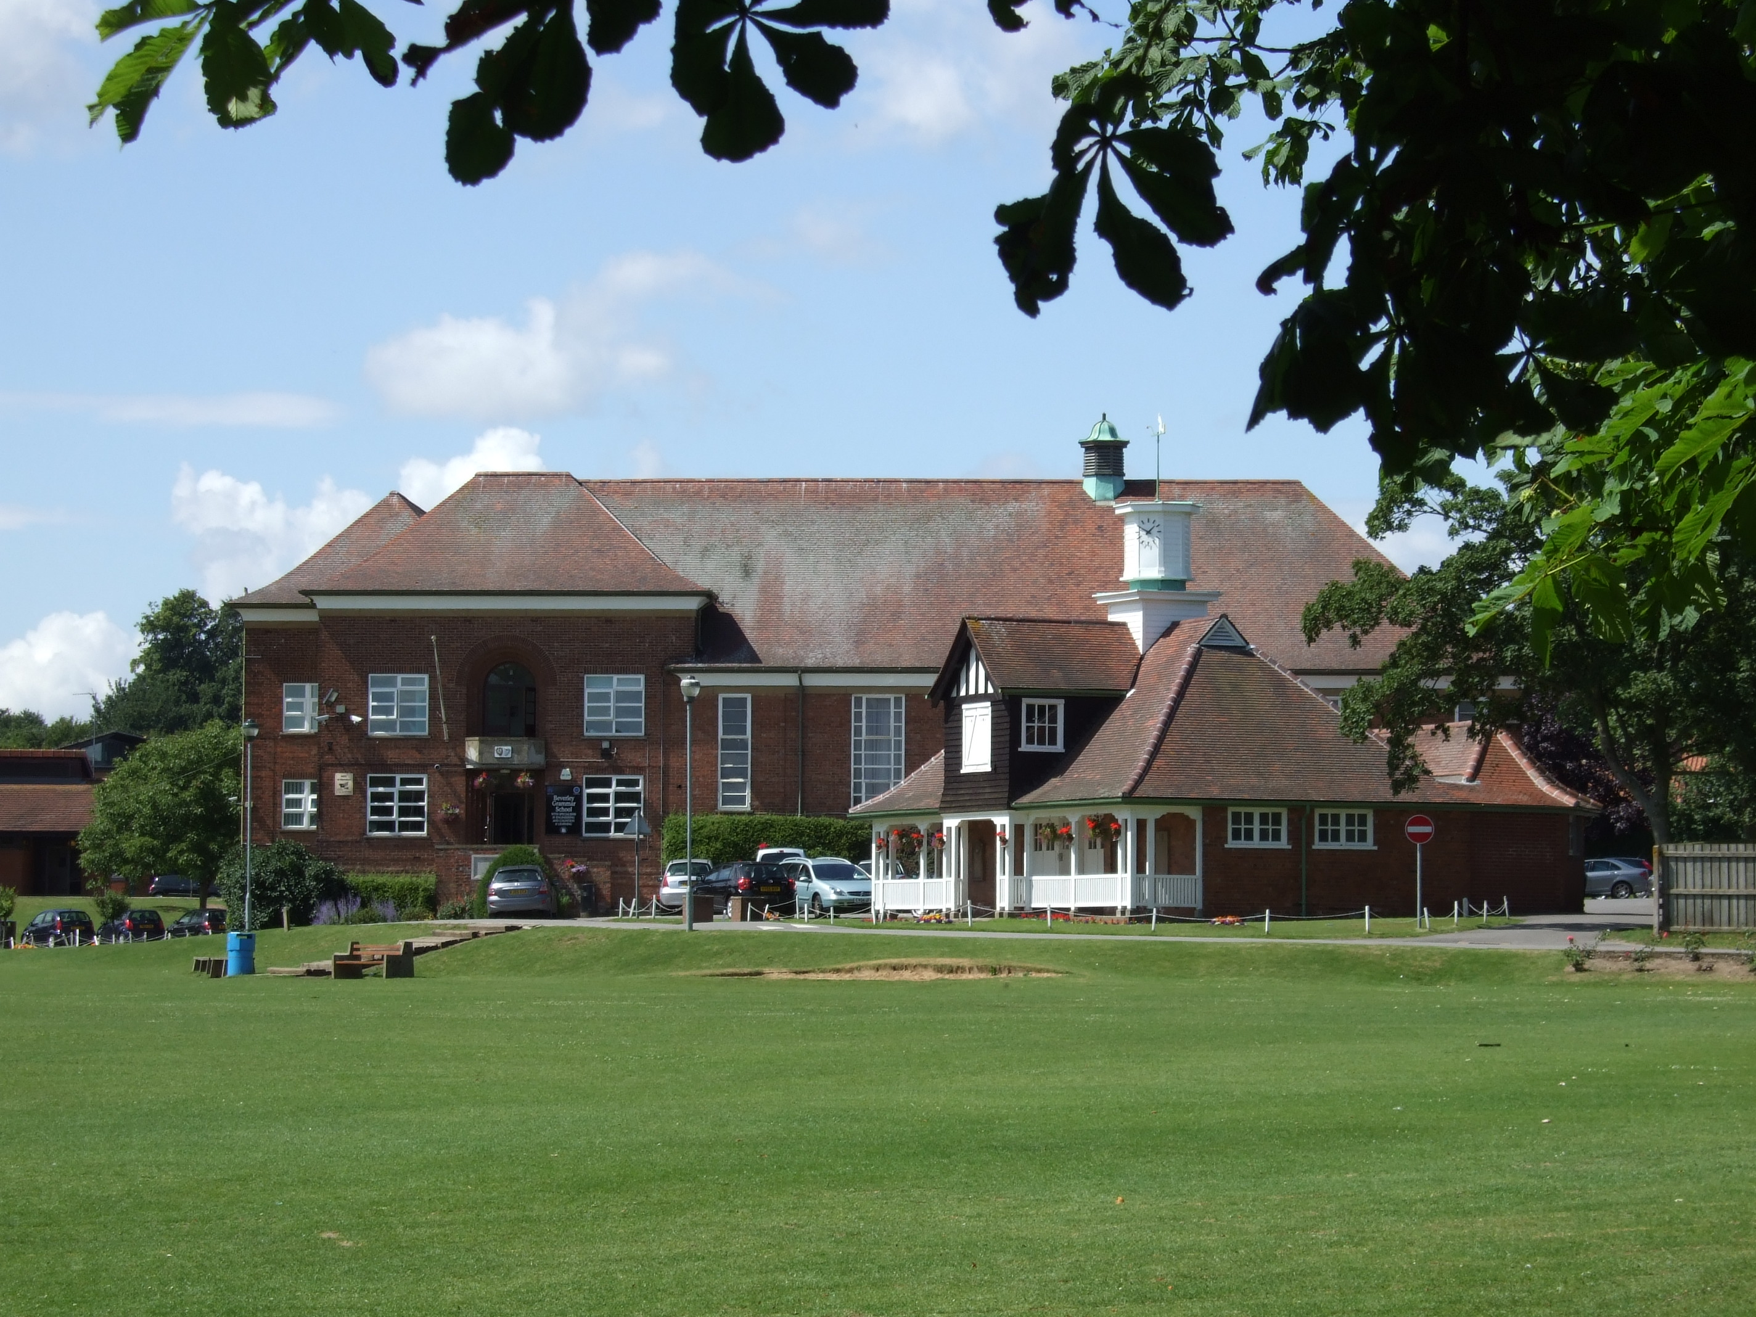

Beverley Grammar School
Queensgate
Beverley
East Yorkshire
HU17 8NF

BEVERLEY GRAMMAR SCHOOL

Art Technician
Recruitment Information Pack

Contents

Letter from Gavin Chappell, Headteacher .............................................................................................. 3

Beverley Grammar School Mission Statement…………………………………………………….. 4

Application Process ………………………………………………………………………………… 5

Vacancy Advert …………………………………………………………………………………….. 6

Department Information ……………………………………………………………………………. 7

Job Description …………………………………………………………………………………….8/9

Person Specification ………………………………………………………………………………… 10



BEVERLEY GRAMMAR SCHOOL
Founded 700AD

Queensgate | Beverley | HU17 8NF
Headteacher Tel: 01482 881531| Fax: 01482 881564
Gavin Chappell email:office@beverleygrammar.co.uk
web:www.beverleygrammar.co.uk

January 2019

Dear Applicant

Thank you for taking an interest in the post of Art Technician, here at Beverley Grammar School. I look forward to receiving your application form.

Beverley Grammar School is an all boys’ 11-18 comprehensive school situated in the picturesque historic market town of Beverley. It operates a joint sixth form with Beverley High School, an all girls’ school. It prides itself on its ethos and is committed to raising the academic achievements of all our students.

Our Art department is led by an ambitious and inspirational Leader. We are looking for an enthusiastic, organised and experienced technician to support this small but busy department.

The attached documents include a Job Description, Person Specification, details about the Art Department as it currently stands, and a school application form. Please outline in your application how your experience and qualities will match the details given.

I look forward to hearing from you by 10.00am on the closing date 28 January 2019. Interviews will take place on 1st February 2019 and selected candidates will be informed by e-mail. Further details will be provided once shortlisting has taken place.

Yours faithfully
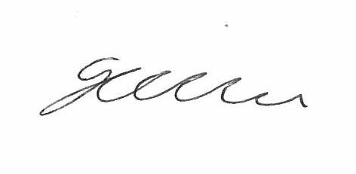

Gavin Chappell
Headteacher

Encs



BEVERLEY GRAMMAR SCHOOL

Mission statement

Our aims are for students to

- Have the ambition and confidence to achieve their dreams
- Act with self-awareness and tolerance
- Have the independence and resilience to overcome barriers

In order to achieve these aims we will strive to

- Set high expectations and standards in all areas of school life
- Provide a consistent, respectful and highly supportive environment
- Create opportunities for students to become leaders
- Value the achievements and contributions of all students
- Make students experience at BGS memorable

BEVERLEY GRAMMAR SCHOOL

THE APPLICATION PROCESS

Completed applications should be:-

Posted to Mrs T. Simkin,
Beverley Grammar School,
Queensgate,
Beverley,
HU17 8NF.

Emailed to apply@beverleygrammar.co.uk

Short-listed candidates will be contacted by email with details of the interview process. If you have not heard from us within 2 weeks of the closing date please assume your application has been unsuccessful.

Queries

If you have any queries on any aspect of the application process or need additional information, please contact Mrs T. Simkin in the first instance on 01482 881531.

THE CLOSING DATE FOR APPLICATIONS IS:

28 January 2019 (10.00 am)
Interviews –1 February 2019


Beverley Grammar School
Queensgate
Beverley
East Riding of Yorkshire
HU17 8NF
Headteacher: Gavin Chappell
Tel: 01482 881531

ART TECHNICIAN

Closing Date: 28 January 2019 (10.00 am)
Interview Date 1 February 2019
Salary: SCP.13, £17,391pa pro-rata to TTO
Contract type: 19 Hours per week, Permanent

Beverley Grammar School is a popular 11–18 boys’ comprehensive with a Joint Sixth form with the neighbouring girls’ school. We provide a consistent, respectful and highly supportive environment that enables our students to realise their ambitions.
We are seeking to appoint an organised and experienced Technician to work in our small but busy Art Department from early 2019. We are looking for someone who is positive, energetic, has good interpersonal skills and a genuine interest in the visual arts. A qualifications in art & design is an essential requirement of this post.
Further details and application forms are available at www.beverleygrammar.co.uk Completed forms should be posted to Mrs T. Simkin, or emailed to apply@beverleygrammar.co.uk

Beverley Grammar School is committed to safeguarding and promoting the welfare of children, young people and vulnerable adults. Clearance from the Disclosure and Barring Service is required prior to appointment.
BEVERLEY GRAMMAR SCHOOL

THE ART DEPARTMENT

The Art & Design Department is a small, dedicated team including a part-time art technician and is housed in light, airy rooms in the oldest part of the school.

The Department works closely together to develop practice, promoting creativity and strong student outcomes across the school and beyond.

The skills and knowledge of art and design processes currently taught within the department include drawing, painting, printing, sculpture techniques, graphic and illustration-based work.

We actively promote student engagement with visual arts both within school and beyond the classroom; such as extra-curricular clubs, exhibitions, trips and the use of social media.

All of our students study Art & Design in years 7,8 & 9. In KS4 we offer AQA GCSE Art & Design as an option subject. This is a very popular course with good numbers taking the subject each year.

At A Level, we join with our sister school, Beverley High School, and therefore teach boys and girls. The uptake at A Level is high. Often 50% or more of the A Level students are boys, which reflects the high value that our students place upon our subject.

Our results over the last few years have been exceptionally good and we perform significantly above national levels. This success is founded upon our expertise in teaching boys. Inventive and highly personalised teaching and accurate assessment are key aspects of our approach.

The department celebrates creative art, and uses digital technology to support diverse areas of the curriculum.

BEVERLEY GRAMMAR SCHOOL

Job Title: Art Technician

Location: Beverley Grammar School, Queensgate, Beverley

Grade: 13

Hours: 3 days (19 hours)
8.30am – 3.50 daily (1 hour lunch) -TTO

PURPOSE AND SCOPE:

To work under the direction of the Leader of Art, to provide a support service to the Art Department enabling a safe and well equipped environment for practical work to support the teaching of Art to all students.

MAIN DUTIES AND RESPONSIBILITIES

- Assisting with the preparation of classrooms ensuring they are equipped and prepared for lessons including the preparation of materials and apparatus which may be required for demonstrations or practical work.
- Facilitate small groups of students through specialist art processes and techniques under the direction of the Art Teachers.
- The monitoring of stock levels, ordering, checking deliveries and storing of art supplies.
- Maintaining art materials and equipment in good working order for use within the classroom.
- Maintaining displays of artwork throughout the school including classrooms, offices reception and school corridors.
- Display artwork for exhibition and examinations.
- Framing, packaging and posting artwork to exhibitions and examination boards.
- Storing examination and coursework as appropriate.
- Assisting in the stocking, transporting and distribution of all items used within the Art Department.

GENERAL DUTIES

- To support a wide range of art department activities including events, preparation days and examinations. Labelling and photography of Art Work as required.
- To be computer literate and able to record and manage stock in accordance with computerised procedures.
- To perform other duties as reasonably corresponds to the general character of the post and are commensurate with its level of responsibility.

This job description will be kept under review and may be amended from time to time, following consultation with the post holder, to reflect changing needs of the school.

Date approved | January 2019
Headteacher: | Gavin Chappell

Postholder:
Date:

BEVERLEY GRAMMAR SCHOOL
ART TECHNICIAN -Person Specification

Criteria | Essential | Desirable
Qualifications:  - Educated to GCSE grade A-C standard or equivalent in English and mathematics.  - Qualification in an Art Specialism.  - Further education qualification/s in relevant field.  - A willingness to undertake training as required. | Y  Y  Y | Y
Experience:  - Experience of working as an Art Technician  - Experience of working in a school or similar establishment.  - Ability to proficiently use office computer and software including word-processing, photographic printing and internet systems | Y | Y  Y
Skills/Attributes:  - Ability to work unsupervised and as part of a team  - Good verbal and written communication skills.  - Ability to set up equipment for demonstrations.  - Ability to work on and set up displays/exhibitions  - Able to order and manage stock  - Able to work flexibly to support others and respond to unplanned situations.  - Efficient and meticulous in organisation.  - Ability to build and form good relationships with students, and colleagues.  - Must be of smart appearance. | Y  Y  Y  Y  Y  Y  Y  Y  Y

