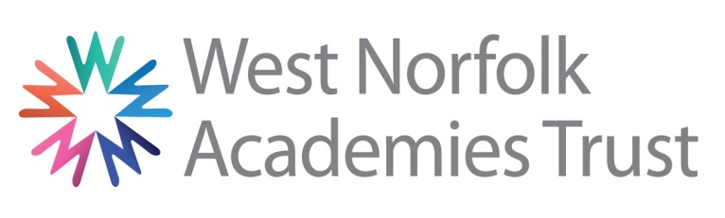

Please refer to our Application Information Document for details on completing and returning your application

Employment Application Form : Part 3

We are committed to safeguarding and promoting the welfare of children and young people and expect all staff and volunteers to share this commitment.

Please complete the form in black ink or type
Vacancy Job Title
Part 3: Equality and Diversity Monitoring
Collection of equality information is solely for monitoring purposes to ensure that our policies and procedures are effective. We also collect this data in accordance with the general and specific public sector equality duties under the Equality Act 2010. Any data you enter onto this monitoring form will only be used for monitoring purposes and will not be used in assessing and/or scoring your application or during the interview process. This information is kept confidentially and access is strictly limited in accordance with the General Data Protection Regulation 2018 (GDPR), as outlined in Part 2, Section 3.
Ethnicity | Workforce Census Code |  | Please Insert an X |  | Sexual Orientation | Please Insert an X
White | WBRI | British/English/Welsh/Northern Irish/Scottish |  |  | Bi-Sexual
 | WIRI | Irish |  |  | Gay Man
 | WIRT | Traveller of Irish Heritage |  |  | Gay Woman
 | WROM | Gypsy/Roma |  |  | Heterosexual
 | WOTH | Any other White background |  |  | Other
Mixed | MWBC | White and Black Caribbean |  |  | Prefer not to say
 | MWBA | White and Black African
 | MWAS | White and Asian |  |  | Gender | Please Insert an X
 | MOTH | Any Other Mixed background
Asian or Asian British | AIND | Indian |  |  | Female
 | APKN | Pakistani |  |  | Male
 | ABAN | Bangladeshi |  |  | Transgender
 | CHNE | Chinese |  |  | Prefer not to say
 | AOTH | Any other Asian background |  |  | Personal Relationship | Please Insert an X
Black or Black British | BCRB | Black Caribbean
 | BAFR | Black African |  |  | Single
 | BOTH | Any other Black background |  |  | Living Together
Other ethnic group | ARAB | Arab |  |  | Married
 | CHNE | Chinese |  |  | Civil Partnership
 | REFU | Refused/Prefer not to Say |  |  | Prefer not to say
 | OOTH | Any other ethnic group

Religion or belief | Please Insert an X
No Religion
Christian (including Church of England, Catholic, Protestant and all other Christian denominations)
Buddhist
Hindu
Jewish
Muslim
Sikh
Any Other Religion (write in)
Prefer not to say

Disability  Do you consider that you have a disability? | Please Insert an X
Yes – Please complete the grid below
No
Prefer not to say
My disability is:

Physical Impairment
Sensory Impairment
Mental Health Condition
Learning Disability/Difficulty
Longstanding illness
Other
Prefer not to say

PLEASE RETURN THIS, ALONG WITH PART 1 AND PART 2 OF THE APPLICATION FORM, TO recruitment@westnorfolkacademiestrust.co.uk or
HR DEPARTMENT, WEST NORFOLK ACADEMIES TRUST, SPRINGWOOD HIGH SCHOOL, QUEENSWAY, KINGS LYNN, PE30 4AW

